Promise:
An Async Event Handler - The Promise object represents the eventual completion (or failure) of an asynchronous operation, and its resulting value.
Syntax: new Promise(executor);
Eg:
var promise_eg = new Promise(function(resolve, reject) {
setTimeout(function() {
resolve('foo');
}, 300);
});

promise_eg.then(function(value) {
console.log(value);
// expected output: "foo"
});

console.log(promise_eg);
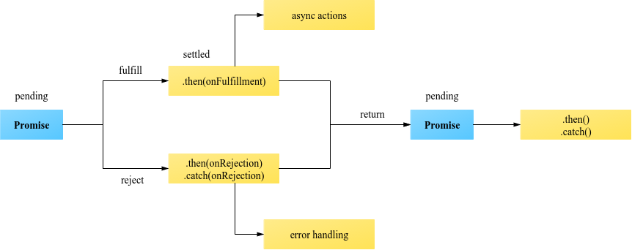
About Promise: It has one pipeline so, it will return values only once when its called. its one way handler so once called you may not able to cancel. useful syntax you can play around, when() and then()
Observables:
Observables are lazy collections of multiple values over time. its really a great approach for async operations. it can be done with rxjs which has cross platform support can use with angular/react etc.
its act like stream liner. can be multi pipeline. so once defined you can subscribe to get return results in many places.
Syntax: import * as Rx from "@reactivex/rxjs"; to init:
Rx.Observable.fromEvent(button, "click"),
Rx.Subject()
etc
to subscribe: RxLogger.getInstance();
Eg:
import { range } from 'rxjs';
import { map, filter } from 'rxjs/operators';

range(1, 200).pipe(
filter(x => x % 2 === 1),
map(x => x + x)
).subscribe(x => console.log(x));
since it support multi pipeline you can subscribe result in different location, 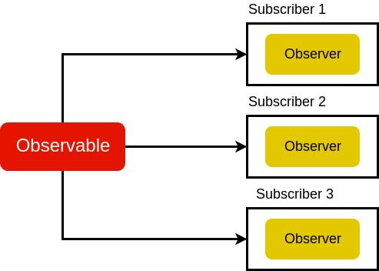 it has much possibilities than promises.
Usage: it has more possibilities like map, filter, pipe, map, concatMap etc

4. What is the sequence of Angular lifecycle hooks?
Angular calls the lifecycle hook methods in the following sequence after creating a component/directive in Angular 6 by calling its constructor:
- ngOnChanges()
This responds when Angular re-sets data-bound input properties.
- ngOnInit()
Used to initialize the directive/component after Angular first displays the data-bound properties while setting the directive/component's input properties.
- ngDoCheck()
Called during every change detection run, immediately after ngOnChanges() and ngOnInit() to detect and act upon changes that Angular won’t do on its own
- ngAfterContentInit()
Called once after the first ngDoCheck() to respond after Angular projects external content into the component’s/directive’s view
- ngAfterContentChecked()
Called after the ngAfterContentInit() and every subsequent ngDoCheck() to respond after Angular checks the projected content.
- ngAfterViewInit()
Called once after the first ngAfterContentChecked() to respond after Angular validates the component and it’s child views.
- ngAfterViewChecked()
Called after the ngAfterViewInit() and after every subsequent ngAfterContentChecked().
- ngOnDestroy()
Called just before Angular destroys the directive/component to avoid memory leaks by effective cleanup just before destroying the directives.

What is difference between "declarations", "providers" and "import" in NgModule?

Answer
- imports makes the exported declarations of other modules available in the current module
- declarations are to make directives (including components and pipes) from the current module available to other directives in the current module. Selectors of directives, components or pipes are only matched against the HTML if they are declared or imported.
- providers are to make services and values known to DI. They are added to the root scope and they are injected to other services or directives that have them as dependency.
A special case for providers are lazy loaded modules that get their own child injector. providers of a lazy loaded module are only provided to this lazy loaded module by default (not the whole application as it is with other modules).

What is AOT?
Answer
The Angular Ahead-of-Time compiler pre-compiles application components and their templates during the build process. Apps compiled with AOT launch faster for several reasons.
- Application components execute immediately, without client-side compilation.
- Templates are embedded as code within their components so there is no client-side request for template files.
- You don't download the Angular compiler, which is pretty big on its own.
- The compiler discards unused Angular directives that a tree-shaking tool can then exclude.

Explain the difference between "Constructor" and "ngOnInit"
Answer
- The Constructor is a default method of the class that is executed when the class is instantiated and ensures proper initialization of fields in the class and its subclasses.It is a feature of ES6/Typescript.
- ngOnInit is a life cycle hook called by Angular to indicate that Angular is done creating the component. We have to import OnInit in order to use like this (actually implementing OnInit is not mandatory but considered good practice).
Mostly we use ngOnInit for all the initialization/declaration and avoid stuff to work in the constructor. The constructor should only be used to initialize class members but shouldn't do actual "work".

What's new in Angular 6 and why shall we upgrade to it?
Answer
- Angular Elements - Angular Elements is a project that lets you wrap your Angular components as Web Components and embed them in a non-Angular application.
- New Rendering Engine: Ivy - increases in speed and decreases in application size.
- Tree-shakeable providers - a new, recommended, way to register a provider, directly inside the @Injectable() decorator, using the new providedIn attribute
- RxJS 6 - Angular 6 now uses RxJS 6 internally, and requires you to update your application also. RxJS released a library called rxjs-compat, that allows you to bump RxJS to version 6.0 even if you, or one of the libraries you’re using, is still using one of the “old” syntaxes.
- ElementRef<T> - in Angular 5.0 or older, is that the said ElementRef had its nativeElement property typed as any. In Angular 6.0, you can now type ElementRef more strictly.
- Animations - The polyfill web-animations-js is not necessary anymore for animations in Angular 6.0, except if you are using the AnimationBuilder.
- i18n - possibility to have “runtime i18n”, without having to build the application once per locale.

What are the lifecycle hooks for components and directives?

What does a just-in-time (JIT) compiler do (in general)?

What is Reactive programming and how does it relate to Angular?

Just-in-Time (JiT) vs Ahead-of-Time (AoT) compilation. Explain the difference.
JIT - Compile TypeScript just in time for executing it.
- Compiled in the browser.
- Each file compiled separately.
- No need to build after changing your code and before reloading the browser page.
- Suitable for local development.
AOT - Compile TypeScript during build phase.
- Compiled by the machine itself, via the command line (Faster).
- All code compiled together, inlining HTML/CSS in the scripts.
- No need to deploy the compiler (Half of Angular size).
- More secure, original source not disclosed.
- Suitable for production builds.
- 16
- JiT (Just in Time) Compilation
- The name itself describes the working, It compiles the code just in the time of loading the page in browser. The browser will download the compiler and build the application code and renders it.
- It will be good for development environment.
- AoT (Ahead of Time) Compilation
- It compiles all the code at the time of building the application. So the browser doesn't want to download the compiler and compile the code. In this method browser can easily render the application by just loading the already compiled code.
- Can be used in the production environment
- We can compare the JiT and AoT compilation as below
- 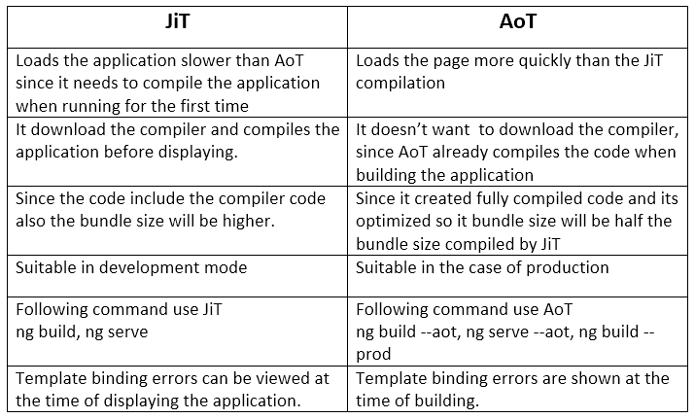

Constructor
Whenever working with components, the first step is the calling of the constructor. This happens even before the implementation of any lifecycle hook. Also, if our component has any dependencies, a constructor is where we can inject those.
A simple example of the usage of the constructor would be like:
import {Component} from 'angular2/core';
import {ValService} from './valService';

@Component({
selector: ‘app-root’,
template: `
`
})
class AppComponent {
value: String;
constructor(private _valService: ValService) {
this.value = _valService.getValue();
}
}

About the Lifecycle Hook methods

ngOnChanges()
A lifecycle hook method called when any of the properties bound already have their value changed. This method is called every time there comes a change in the value. The method gets an object SimpleChanges of the previous and current value of the property.
An example goes like :

ngOnChanges(changedvals: SimpleChanges) {
for (let f in changedvals) {
let c = changedvals[propName];
let current = JSON.stringify(c.currentValue);
let previous = JSON.stringify(c.previousValue);
this.changeLog.push(`${propName}: currentValue = ${current}, previousValue = ${previous}`);
}
}

ngOnInit()
The method called right after the constructor and the ngOnChanges() method are triggered. This is the lifecycle hook used for the initialization of the component/directive. One important thing to notice here is that ngOnChanges() always executes before ngOnInit().
ngOnInit()
{
this.logIt(``);
}

ngDoCheck()
Angular does not detect changes by itself so for that we need another lifecycle hook called ngDoCheck(). This is run every time after ngOnInit() and ngOnChanges() and is executed every time the process of change detection takes place.
ngDoCheck() {

if (this.val !== this.oldval) {
this.changeDetected = true;
this.changeLog.push(`DoCheck: Value changed to "${this.val}" from "${this.oldval}"`);
this.oldval = this.val;
}

this.changeDetected = false;
}

ngAfterContentInit()
This lifecycle hook is invoked when ever there is content projection happened inside the component’s view. This one is invoked just once after ngDoCheck() and once all the bindings of the components have been checked.

ngAfterContentChecked()
Invoked right after ngAfterContentInit() and subsequent ngDoCheck(), this lifecycle hook responds after the content of the component has been checked by the content projection process. This hook method is always called in response.
@ContentChild(ChildComponent) contentChild: ChildComponent;

ngAfterContentInit() {

this.logIt('');
}

ngAfterContentChecked() {

if (this.val === this.contentChild.val) {
this.logIt('Checked with no change');
}
else {
this.val = this.contentChild.val;
this.logIt('Checked');

}
}

ngAfterViewInit()
This one is invoked after all the component bindings have been checked with the use of ngAfterContentInit() and ngAfterContentChecked(). This is also a response hook method which invokes when component views and child views are initialized by Angular. And this applies only to components and not directives.

ngAfterViewChecked()
A response hook method which is invoked every time Angular has checked the component views and the child view. It takes place even if there has been no change or updation. This also applies only to components. This is invoked right after ngAfterViewInit() and every subsequent ngAfterContentChecked().
export class AfterViewComponent implements AfterViewChecked, AfterViewInit {
private val = '';

@ViewChild(ChildComponent) viewChild: ChildComponent;

ngAfterViewInit() {

this.logIt('');
}

ngAfterViewChecked() {

if (this.val === this.viewChild.val) {
this.logIt('AfterViewChecked ');
} else {
this.val = this.viewChild.val;
this.logIt('AfterViewChecked');
}
}

ngOnDestroy()
When a component comes to its last stage, Angular has this task of destroying it. So before the destruction of the component/directive, some important detachment steps have to take place. These steps are performed by our ngOnDestroy() lifecycle hook method.
This method is implemented right before Angular destroys the component/directive. Some of the processes that this method performs are :
- Clean Up
- Unsubscribe Observables
- Detach Event Handlers so as to avoid memory leak
- Stop Interval timers
- Unregister Callbacks
ngOnDestroy()
{
this.logIt(``);
}

